**Project:**

Working with CSV, Pandas & MySQL

**Description:**

This project is intended to demonstrate how to work with CSV, Pandas and MySQL. With this project you will download random data using Faker module, store that data to CSV and retrieve it using Pandas. The same information retrieved is then transferred to MySQL database. You can again query the MySQL table to confirm that data transferred is same as what was in the original CSV file.

The project is done using Python as the programming language, CSV and MySQL server.

**Installation:**

In case you need to have a full end-to-end experience with the system, you will require to install MySQL in your computer environment.

For the text file, please change the location of the file to point to your own computer environment.

**How to Use This Project:**

Once you have the environment set, you just run the program.

1. The program will download the faker random data. The data downloaded will not be displayed on the screen but the system will report that the data has been saved. This saving happens to the CSV file. In this case we Write CSV File From a Dictionary With csv
2. We then read CSV Files With pandas

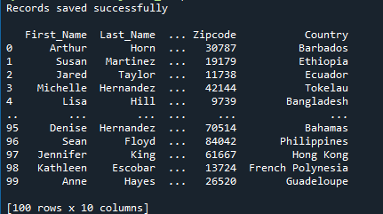

1. Using the data that has been read from the CSV file above, we then push it to the MySQL database

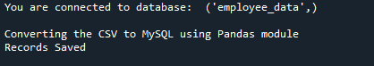

The saved data will look like this.

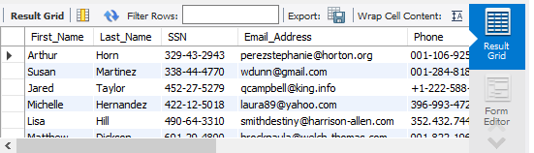

1. You will then retrieve the data from the database and display on the screen

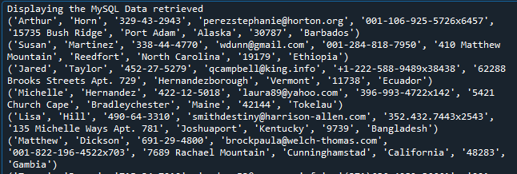

**Author:**

Nicholas Okello